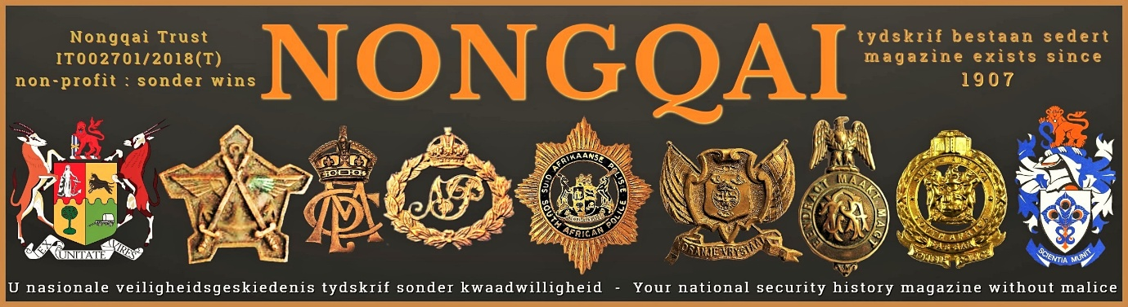
EDITORIAL BOARD
The Editor-in-Chief of Nongqai Magazine is retired Brigadier Hennie Heymans of the South African Police. Brigadier Heymans was a SAPS representative on the Secretariat of the State Security Council, and for decades the Editor of Nongqai.
The historian Henning van Aswegen is the Editor of Nongqai, and the Operations Manager Dr. Willem Steenkamp. Nongqai's editorial staff are Eben Mare, Col. Logan Govender, Helmoed Romer Heitman, and Renè Geyer.
EDITORIAL POLICY
An opinion expressed by any member of the Editorial Staff or correspondents is their personal opinion and responsibility. It is the stated aim of Nongqai's to accurately record South Africa's National Security history and thus preserve it for posterity. We use the articles and stories as received from our correspondents and contributors, and we only correct spelling errors. Nongqai preserves the stories in the form and context in which they are received. Nongqai is not a literary or scientific journal, but a forum and platform for historical writing and debate. Nongqai is a non-profit educational publication that is distributed free of charge and therefore retains the copyright, authorship, and intellectual property of its articles and photos.

CONTACT DETAILS
Email: Intel@Nongqai. org. Tel: 082-344-5641. Websites: Nongqai.org

